**Code:**

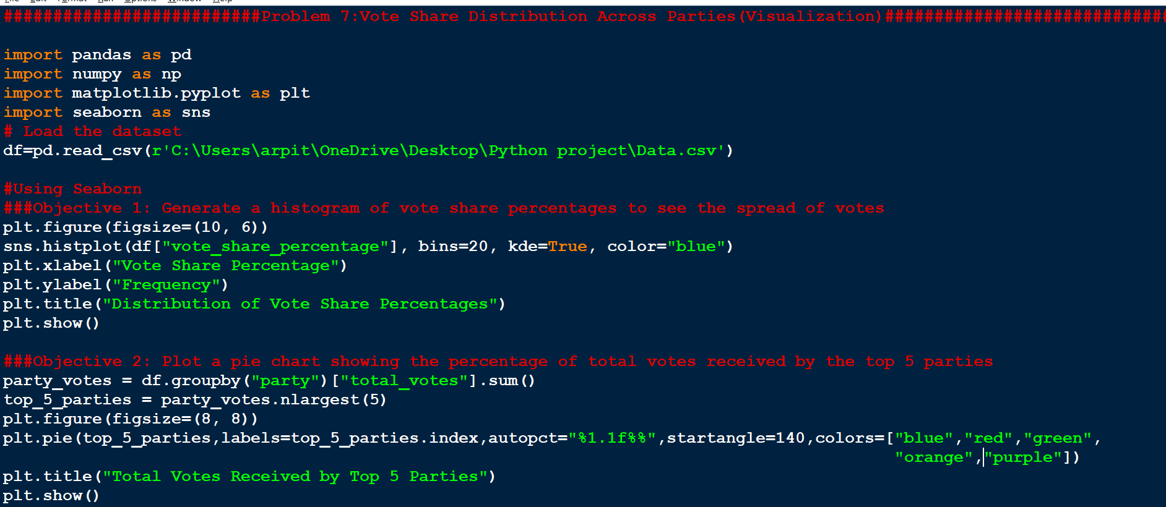

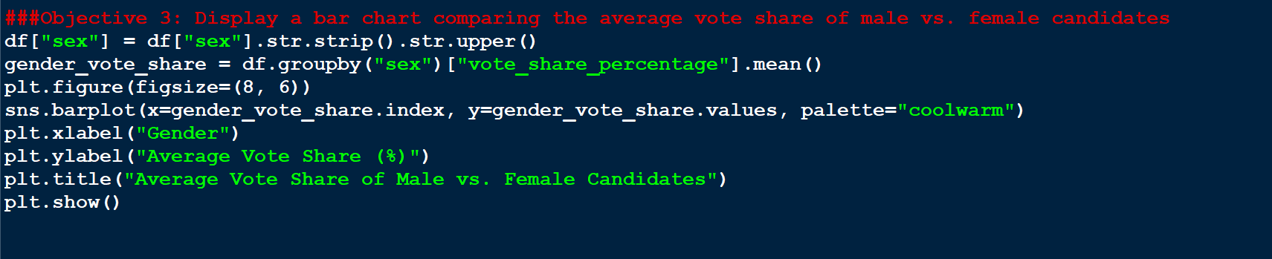

##########################Problem 7:Vote Share Distribution Across Parties(Visualization)#############################################

import pandas as pd

import numpy as np

import matplotlib.pyplot as plt

import seaborn as sns

# Load the dataset

df=pd.read_csv(r'C:\Users\arpit\OneDrive\Desktop\Python project\Data.csv')

#Using Seaborn

###Objective 1: Generate a histogram of vote share percentages to see the spread of votes

plt.figure(figsize=(10, 6))

sns.histplot(df["vote_share_percentage"], bins=20, kde=True, color="blue")

plt.xlabel("Vote Share Percentage")

plt.ylabel("Frequency")

plt.title("Distribution of Vote Share Percentages")

plt.show()

###Objective 2: Plot a pie chart showing the percentage of total votes received by the top 5 parties

party_votes = df.groupby("party")["total_votes"].sum()

top_5_parties = party_votes.nlargest(5)

plt.figure(figsize=(8, 8))

plt.pie(top_5_parties,labels=top_5_parties.index,autopct="%1.1f%%",startangle=140,colors=["blue","red","green",

"orange","purple"])

plt.title("Total Votes Received by Top 5 Parties")

plt.show()

###Objective 3: Display a bar chart comparing the average vote share of male vs. female candidates

df["sex"] = df["sex"].str.strip().str.upper()

gender_vote_share = df.groupby("sex")["vote_share_percentage"].mean()

plt.figure(figsize=(8, 6))

sns.barplot(x=gender_vote_share.index, y=gender_vote_share.values, palette="coolwarm")

plt.xlabel("Gender")

plt.ylabel("Average Vote Share (%)")

plt.title("Average Vote Share of Male vs. Female Candidates")

plt.show()

**Output:**

